UV21578.SAM




External Sample Assessment Material

AM20530 - Level 2 Certificate in Hairdressing and Beauty
Therapy (VRQ)
(601/0556/2)

MOCK PAPER 1
UV21578 – Understanding the hair and beauty sector

Please write clearly in block capitals.

Centre number
Learner number
Learner surname
Other names
Learner signature
Date

Time allowed: 90 minutes Total marks: 60 marks

Instructions
• Use black ink
• Complete the boxes at the top of this page
• Answer all questions
• You must answer questions in the spaces provided
• Do all rough work in this book. Cross through any work you do not want to be marked

Information
• The marks for each question are shown in brackets

Advice
• Please read each question carefully before answering

S 001 AM 201 P001 LE100

Figure 1

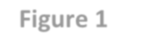
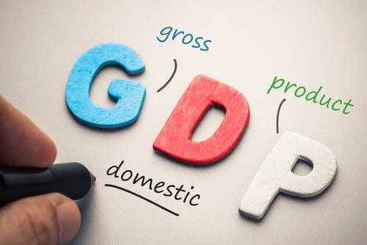
1 (a) Describe Gross Domestic Product (GDP)

[3marks]

1 (b) Describe how retail and fashion contribute to the economy
(3 marks)

Total for Question 1a&b = 6 marks

Setting up a new business requires planning and organisation to ensure all legislative and regulatory requirements are adhered to. Business owners have a number of responsibilities and there are serious consequences if businesses are not compliant.

2 (a) Summarise employer’s responsibilities under the Work place (Health and Safety and Welfare) regulations

[3 marks]

Total for Question 2a = 3 marks

2 (b) Describe two responsibilities for a business under the COSHH Act (Control of Substances Hazardous to Health).

[4 marks]

Total for Question 2b = 4 marks

2 (c) Compare the difference between sterilisation and sanitisation.

[2 marks]

Total for Question 2c = 2 marks

2 (d) Identify two types of non-infectious and infectious conditions.

[4 marks]

Total for Question 2d = 4 marks

Total for Question 2e = 3 marks

Total marks for Question 2 = 16 marks

3 (a) Outline the effects of the following products on the hair and skin:

• Temporary colouring product
• Moisturiser

[2 marks]

Total for Question 3a = 2 marks

3 (b) Outline the functions of a mascara and foundation
(3 marks)

Total for Questions 3b = 3marks

Total for Question 3 = 5 marks

Martha is in the final year of her GCSEs and has been asked by her form tutor what pathway she wants to take after her GCSEs. Martha is unsure and needs to explore all education options.

4 (a) Compare and appraise the educational opportunities available in private training and further and higher education.

[10 marks]

Total for Question 4a = 10 marks

Total for Question 4 = 10 marks

Over 2.4 million apprenticeships were started between 2010-2011 and 2014-2015. The Government has set out its intention to create 3 million new apprenticeships by 2020.

5 (a) Evaluate the advantages of being an apprentice within the hair and beauty industry.

[4 marks]

Total for Question 5a = 4 marks

Total for Question 5 = 4 marks

5 (b) Describe how training and education relate to the hair and beauty sector.

[3 marks]

Total for Question 5b = 3 marks

5 (c) Outline the role of makeup artist

[2 marks]

Total for Question 5c = 2 marks

Total marks for Question 5 = 9 marks

Layla and Georgina are considering setting up their own hair and beauty business. Layla has 20 years hairdressing experience and Georgina has 7 years beauty therapy experience. They want to go into business together but are not sure what would be the best type of business. They are going to look into a partnership business and a franchise business.

6 (a) Describe these two business ownership.

[4 marks]

Total for Question 6a = 4 marks

Total for Question 6 = 4 marks

Lucy has recently qualified as a hairdresser and is exploring her employment options and understanding the skills and attributes she needs to carry out the job. She is not sure if she wants to become a mobile hairdresser or work in the city that is 5 miles from her home.

7 (a) Critique the mobile business option and analyse the benefits of accepting the full time employed position.

[7 marks]

7 (b) Describe the skills and attributes needed to be a hairdresser
(3 marks)

Total for Question 7a = 7 marks
Total for Question 7b = 3 marks
Total for Question 7 = 10 marks

TOTAL FOR PAPER = 60 MARKS

END OF EXAM

